

Georgia’s Judicial Services Portal

Functional Specifications Document

Revision History
4/25/16 | 1st draft based on AOC Meeting – D. Griffith
5/5/16 | 2nd draft based on AOC Meeting – D. Griffith
5/11/16 | 3rd draft based on committee members’ feedback – M. Schwaig
Table of Contents

What is it? 3
Benefits 4
Key Contacts 5
Functional Overview 6
Registered User View 7
1. New User Registration 8
2. Manage Profile 10
3. Sign-On 11
4. Federated Case Search 12
5. Access to Court Services 13
6. Non-Registered User View 15
7. Information Lookup 15
8. SSO Service 17
11. Local Jurisdiction Database 19

What is it?
The Portal itself should simply be a centralized front-end entry point that satisfies the wish of the Judicial Council’s Standing Committee on Technology for a single login process for accessing multiple court e-Access and e-Filing services to the extent those services exist. The portal creates one mechanism that will direct justice system participants to the appropriate web locations. This portal will leverage technology to provide single sign on to those participants. The Portal will also allow users to search for case information through a Federated Case Search.
As proposed, the Portal will be comprised of a directory of information and links related to every Superior, State, Magistrate, Probate and Municipal Court, as well as the Supreme Court and Court of Appeals. For those courts that offer e-Filing and/or e-Access services, the Portal will provide a link to the respective provider(s). For those courts that do not offer e-Filing or e-Access services, the Portal will provide contact information for the court to facilitate manual filing and document access.
The Portal will allow a user to register, create a user account and manage the user profile. In addition, the Portal will provide the ability to search for cases across some or all Superior, State, Magistrate, Probate, and Municipal Courts, as well as the Supreme Court and Court of Appeals.

Benefits
The portal provides a standardized interface and process for accessing multiple disparate service applications.
- Minimal initial development for the onboarding of vendors and courts to the Portal system.
- Meets the requirements for the filing initiative.
- The Portal will integrate with existing Electronic Filing Service Providers (EFSPs) or existing court case management/document management systems.
- Higher adoption because processes and programs would remain unchanged.
- Vendors will continue to manage all support, maintenance, payments and versioning of their respective services.
- Single sign-on functionality that allows portal users to access multiple service providers without having to maintain multiple account credentials
- Existing local vendor relationships remain the same for support functions
- Easily scalable service platform
- Provides a consistent “look and feel” that allows users to interact with courts.

Key Contacts

Team Role | Team Member | Phone | Email
Account Manager | Lloyd Wilkinson | 770-633-8420 | lloyd.wilinson@provenmethod.com
Project Manager | Mike Schwaig | 770-633-8419 | mike.schwaig@proventmethod.com
Business Analyst | David Griffith | 404-860-4224 | david.griffith@provenmethod.com
Project Sponsor | Jorge Basto | 404-657-9673 | jorge.basto@georgiacourts.gov
Staff Contact | Wendy Hosch | 404-656-7788 | Wendy.Hosch@georgiacourts.gov

Functional Overview
The functionality of the individual components that comprise Georgia’s Judicial Services Portal will be defined in each section below.
Georgia’s Judicial Services Portal functional areas include:
- User Interface
- Registered User View
- Non-Registered User View
- Federated Case Search (including Appellate Courts)
- Access to Court Services
  - eFile
  - eAccess
  - Online Payments
- Single Sign On Server
- GJSP Web Service
- State Bar Web Service
- Clerk of Courts Database

Registered User View
The Registered User View is the user interface that an attorney or other registered user will interact with once access has been granted through successful registration and login to the portal.
The Registered User View is comprised of four functional areas:
- New User Registration and User Profile Management
- Single Sign-On (SSO)
- Federated Case Search
- Links to Court Services (e-Filing, e-Access and Online Payments)

1. New User Registration
New User Registration is the process that allows for the creation of a GJSP profile that is registered with and maintained by the GJSP application. The GJSP profile will contain information used to identify each user and grant access to the GJSP and services such as Federated Case Search and court provided services such as e-Filing, e-Access, and Online Payments to the extent they exist.
Users can perform the following actions:
- Users can initiate the New User Registration process.
  - Users can choose to manually create their GJSP Profile.
  - Attorney users can use their State Bar Profile to populate their GJSP profile.
Functional Requirements:
 | Initiate New User Registration
R1.1 | Users shall be able to initiate the new user registration process.
 | Create GJSP Profile
R1.2 | Users will be able to create a GJSP Profile that includes the following fields:  * = Required field; + = Must be unique across all users  - Prefix  - Last Name *  - First Name *  - Middle Name  - Suffix  - Email Address *+  - Password *  - Security Question and Answer (eg: PIN, passphrase, etc.) *  - Georgia Bar Number (if present, must be unique)  - Firm Name *  - Firm Address, City, State, and Zip Code *  - Telephone Number
 | State Bar Profile
R1.3 | Attorney Users can choose to use their existing state bar profile to populate their GJSP profile information.  State Bar profile attributes TBD…

2. Manage Profile
Each customer will have ultimate access to update profile information as needed. Best practices and established processes for updating personal information will be implemented into the Portal.

Users can perform the following actions:
- Users can modify any of the fields listed in R1.2 above.
- Any user action to modify the user’s profile must comply with the rules for required information and unique information as defined in R1.2 above.

Functional Requirements:
 | Manage GJSP Profile
R2.1 | Registered users will be able to maintain their GJSP profile information. User will be permitted to modify and update their GJSP Profile information. User will be permitted to change their account email address and password.

3. Sign-On
Sign-On is the process that allows a registered user to gain access to the GJSP portal services by entering a valid user name and password into the Sign-On form.

User can perform the following actions:
- A registered user can sign on to the GJSP portal with their credentials.
- A registered user can reset their lost password.

Functional Requirements
 | Portal Sign-On
R3.1 | The user will enter their GJSP credentials into the GJSP Sign-On form.
 | Failed Authentication
R3.2 | Users that fail authentication within the Portal Sign-On process will be denied access to any Portal features that require authentication and must be provided with instructions for re-entering GJSP credentials.
 | Successful Authentication
R3.3 | Users that are successfully authenticated will be directed to the GJSP Services page.
 | Reset Password
R3.4 | A user can reset a lost password.

4. Federated Case Search
A Federated Case Search is the process by which a user who has been authenticated with GJSP can search for an existing case that is associated with one of the five levels Georgia State courts (Superior, State, Probate, Magistrate, and Municipal) as well as the Supreme Court and the Court of Appeals.
The results of any search will include Case Number, Court Jurisdiction, Party Names (or case caption) and current status for each case included in the results. No actual documents will be retrieved.
* Note Detailed case information and dockets will not be returned by the Federated Search. Certain jurisdictions may not support Federated Search Services. Federated Search services will be dependent solely on court support.

Users can perform the following actions:
- A user can perform a federated case search.
- A user can view search return results.

Functional Requirements
 | Federated Case Search
R4.1 | User can perform a case search by providing either a case number or party name.
 | Search Scope
R4.2 | The scope of the federated case search will include results from any of the Georgia level courts to include: Superior, State, Magistrate, Probate, and Municipal Courts, as well as the Supreme Court and Court of Appeals.
 | Search Returns
R4.3 | Federated Case Search returns will include Case Number, Court of Jurisdiction, Party Names (or case caption) and current status for each case included in the results.

5. Access to Court Services
Court services are provided by participating courts and their third-party vendors and are accessed through the Access to Court Services area within the GJSP. The Access to Court Services area acts as a simple pass-through to court provided services, to the extent they exist.
Users will access Court provided services by first choosing a jurisdiction located within the State of Georgia, and second, by choosing a case type. Court services that are supported for the chosen jurisdiction and case type will be listed with hyperlinks within the Access to Court Services area.
To access a Court provided service, a user will click the appropriate hyperlink and be directed to the specific web page that provides the service.

User can perform the following actions:
- Display a list of available Court services depending on the selected:
  - Jurisdiction
  - Case Type
- View Clerk of Court Name, Address and Phone Number.
- Choose a service from the displayed list of available services.
Functional Requirements:
 | Display Access to Court Services
R5.1 | 1) Select Jurisdiction: The user will be able to choose the jurisdiction in which they want to e-File, access court documents, or make an Online payment.  2) Select Case Type: (eg: Domestic Relations, General Civil, Traffic)
 | System Response
R5.2 | - Clerk of Courts information is displayed to the user, including the clerk’s name, clerk’s office mailing address and clerk’s office telephone number.  - If services are not supported, a message is displayed to the user directing them to contact the Clerk of Courts.  - If services are supported, then a list of each available Court service (eg: e-Filing, e-Access, Online Payments) with a hyperlink to each is displayed to the user.  - Each hyperlink directs the user to the specific web page within the application that provides the service.

6. Non-Registered User View
The Non-Registered User View is the user interface for users who do not register.
The Non-Registered User View is comprised of one functional area:
- Portal Services Lookup

7. Information Lookup
Non-Registered Users can access local jurisdiction information by first choosing a jurisdiction located within the State of Georgia, and then choosing a case type. The application will perform a simple local jurisdiction address and phone number lookup based upon user input.
User can perform the following actions:
- Display local jurisdiction name, local jurisdiction contact name and position, mailing address, physical address, telephone number based on:
  - Jurisdiction
  - Case Type
Functional Requirements:
 | Local Jurisdiction Lookup
R7.1 | Choose a jurisdiction: The user will be able to choose the jurisdiction. The list of available jurisdictions will match the list defined in R5.1 above.
R7.2 | Choose Case Type: The user will be able to choose the case type. The list of case types will match the list defined in R5.1 above.
R7.3 | View Local Jurisdiction Information: Local jurisdiction name, local jurisdiction contact name and position, mailing address, physical address, telephone number.

8. SSO Service
Single Sign-On (SSO) is a session/user authentication process that permits a user to access any participating court service application through a single set of credentials (username and password combination). The process authenticates the user for court services accessible via the site.
In the context of the GJSP portal, the SSO Service will authenticate a user at the Portal and within each application that provides a court service. Each authenticated user can access Court provided services from the GJSP portal once they have successfully signed in to the Portal.

Functional Requirements
 | Service Authentication
R8.1 | The SSO service will verify the user’s identity. This will be based on username and password combination.
 | Service Authorization
R8.2 | Service will verify whether a user is privileged to access a particular court resource.

10. State Bar Web Service
The Georgia State Bar Web Service will aid in portal adoption rates by making portal registration fast and user friendly. Attorneys that are registered with the state bar will be able to use their existing state bar profile to populate the GJSP profile.
 | State Bar Profile Lookup
R10.1 | An attorney will be able to search for their existing state bar profile from within the GJSP using their state bar number.
 | Populate State Bar Profile to GJSP Profile
R10.2 | Once the record has been retrieved, the user can then choose to populate their GJSP profile with their existing State Bar profile.

11. Local Jurisdiction Database
The GJSP Local Jurisdiction Database will store contact information for all of Georgia’s jurisdictions. Both the Registered User and Non-Registered User views will pull information from this data warehouse to perform local jurisdiction information searches.

Functional Requirements
 | Database Format
R11.1 | TBD
 | Information
R11.2 | The database will store information about local jurisdictions. This information will include the fields defined in R7.3 above.

Georgia Judicial Services Portal Diagram
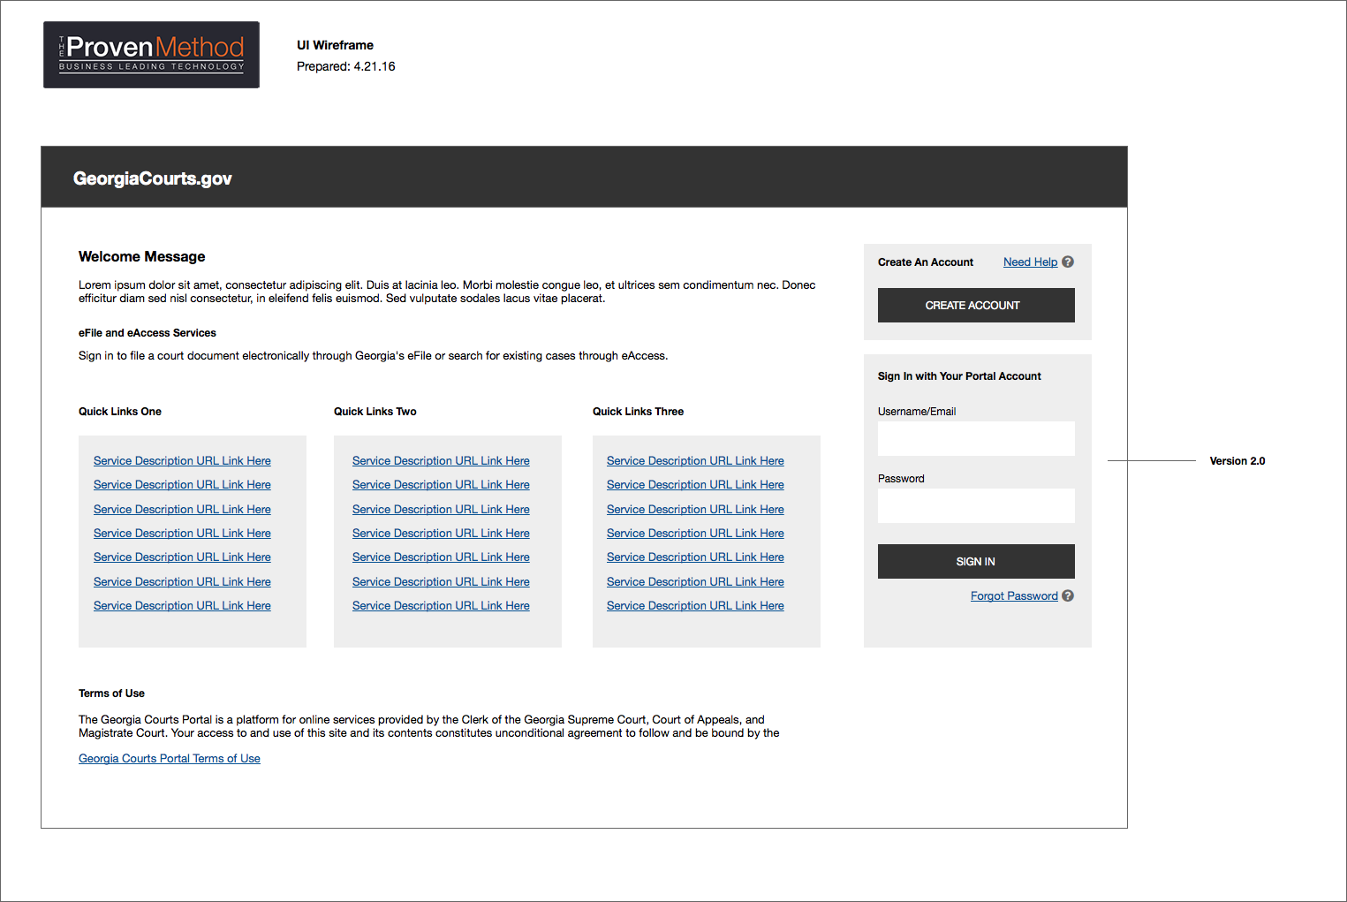

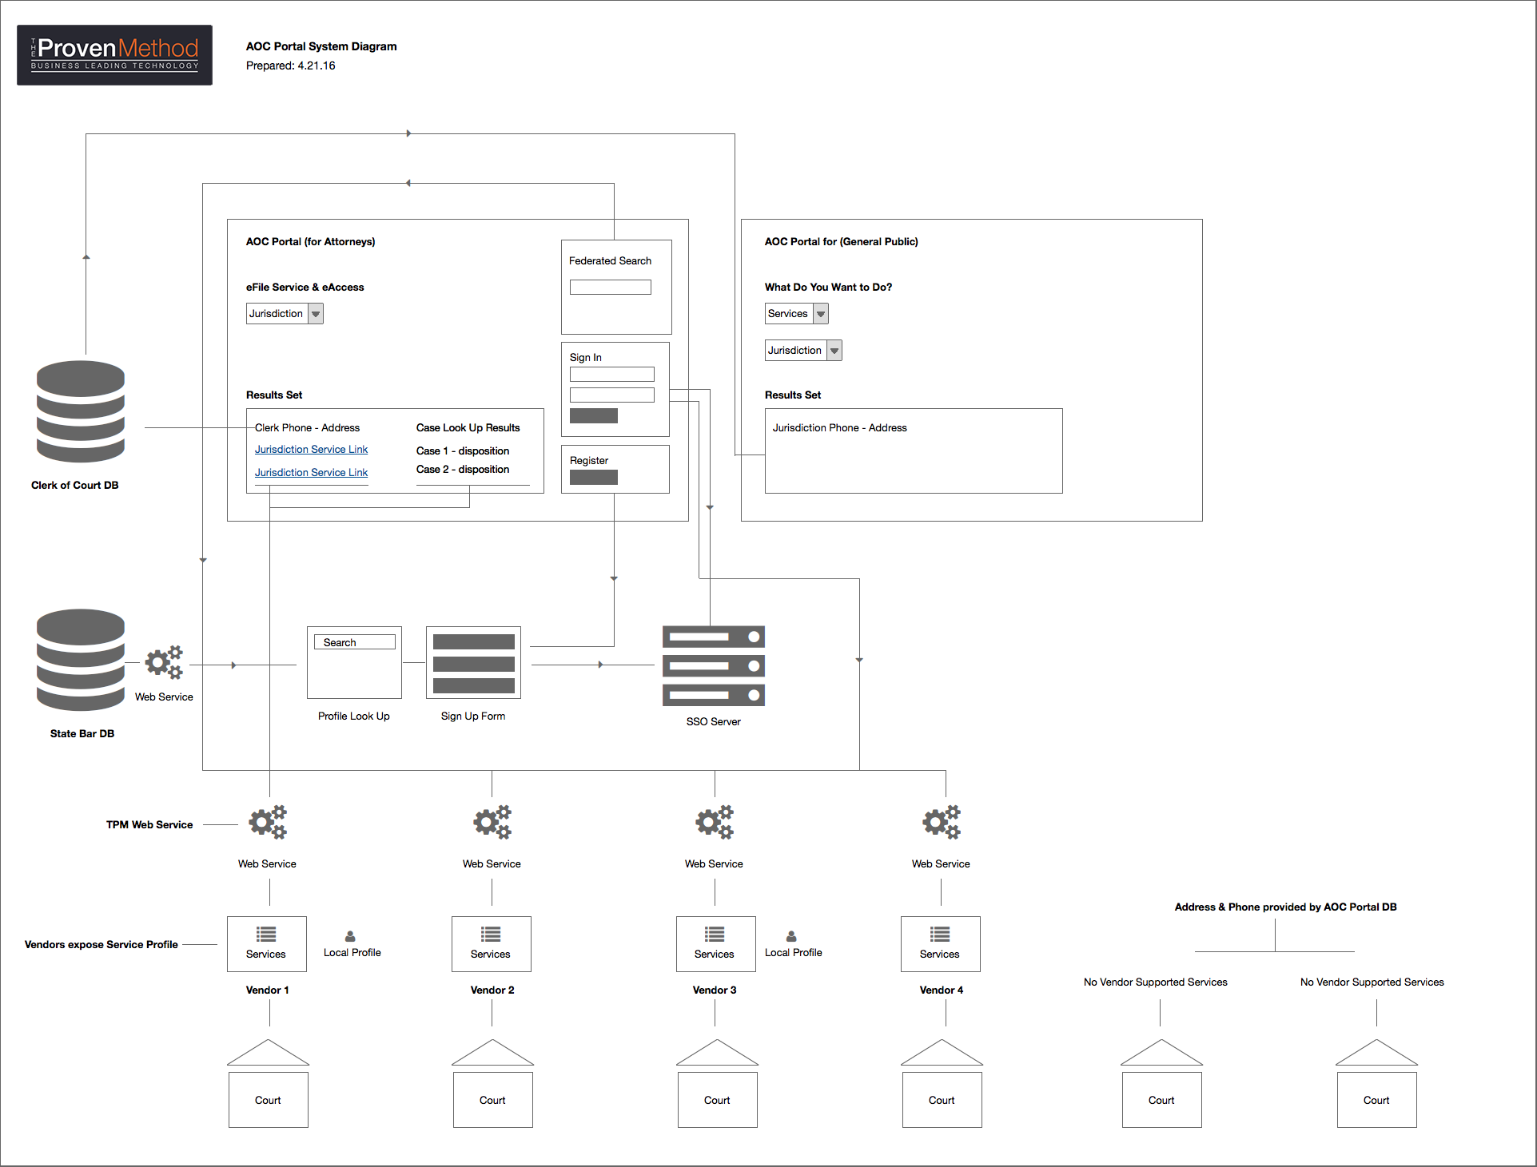

Note:
The diagram above is included for informational purposes only, to illustrate the functional relationship and business process flow among the components of the Judicial Services Portal. It is not a technical spec, nor is this a technical document.

